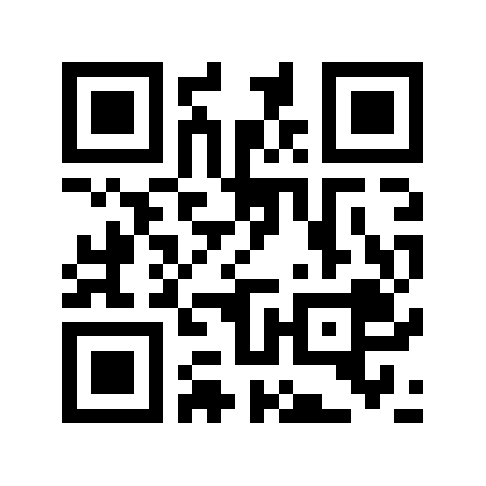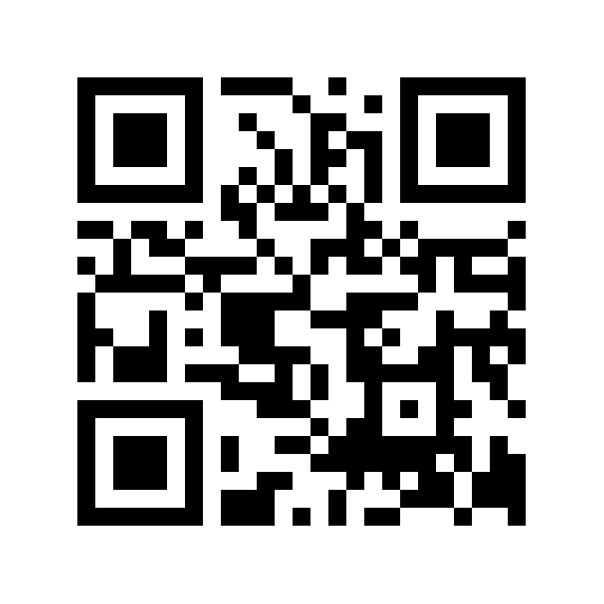
Le Sueur County Snowmobile
Trails Association, Inc.
www.lesueursnowtrails.org
www.facebook.com/LSCSTA

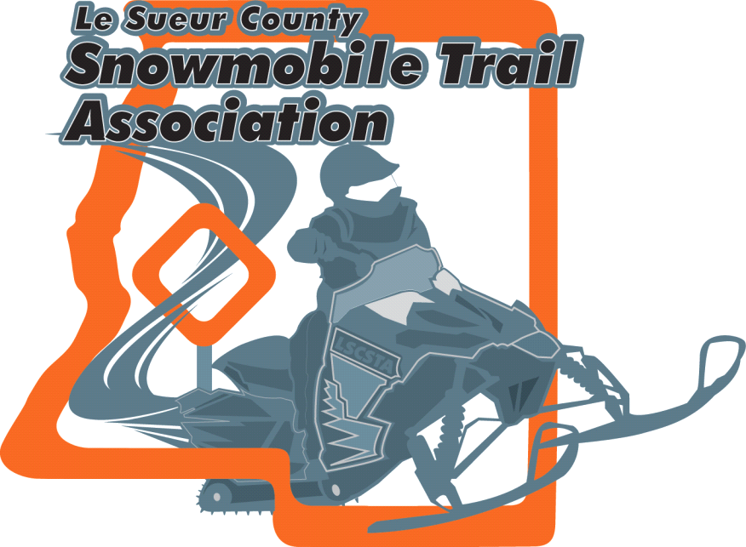
President: Corey Kaderlik
Email: president@lesueursnowtrails.org
Secretary/Treasurer: Dianne Lamont
18902 450th Street
Waterville, Minnesota 56096
Email- diannelebrun@yahoo.com

We would like to invite you to join our club.

We are responsible for installing, removing, maintaining and grooming 145 miles of trails in Le Sueur County. The club relies on fundraisers and membership dues to help support the costs involved. The club has monthly meetings held September - April on the second Monday 7:00 p.m. of each month at the Little Dandy Restaurant in Le Center, MN.

The annual membership dues for the club are $40.00, including your membership to Minnesota United Snowmobilers Association. MnUSA is the state organization that helps the local clubs with the trail system (this includes trying to keep the trails) and dealing with the legislative issues.

Our website: www.lesueursnowtrails.org or check us out on MnUSA’s website www.mnsnowmobiler.org in the club information section.

Please fill this out and return to us tonight or drop it in the mail to the address listed above.
Le Sueur County Snowmobile Trails Association, Inc.
Membership Form

Name: _______________________________________________________

Address: _____________________________________________________

City: __________________________________ State: ____________ Zip: ________________

Home Phone: _______________________________ Cellular Phone: ___________________

Email: _______________________________________ County: _________________________

Number in Family: ________________ Number of snowmobiles: ______________

MnUSA Member Number: ___________ Membership Dues Amount Paid: ________________

